Competitive Shooters of Lake Norman USPSA June 25th, 2026
COURSE DESIGNER: Ike Starnes
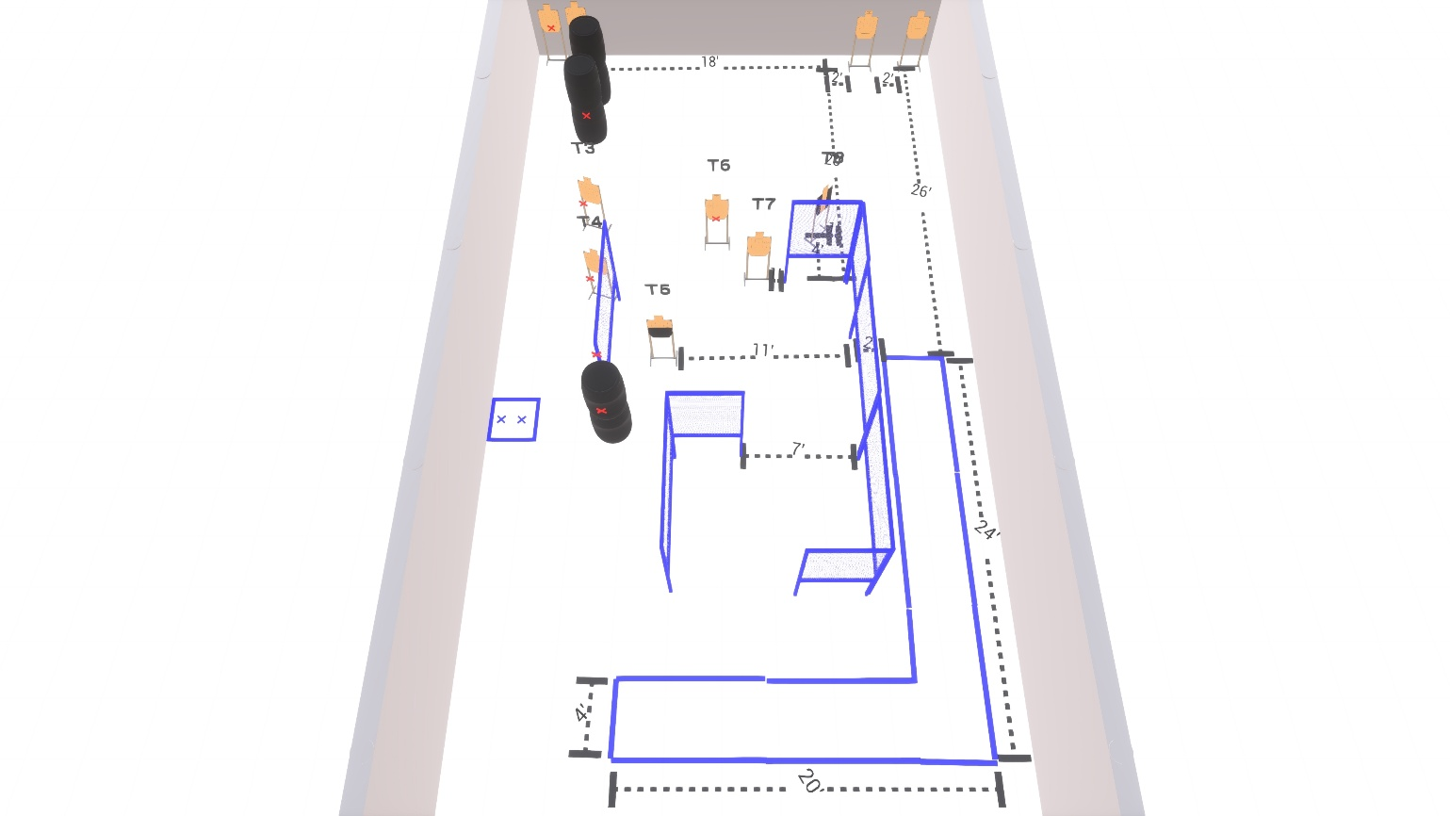

Stage 2
100-point Comstock course.
There are 10 paper targets. Start position is both feet on Xs.
Handgun is loaded and holstered with wrists below belt.
PCC is loaded and held in both hands with stock touching belt.

